Digital Marketing Checklist

Drive
□ SEO □ SEM □ PPC □ Social □ Print □ Sales (In-Person) □ Broadcast

Convert
□ UX □ Landing pages □ CTA’s □ Content □ Customer Journey

Measure
□ Analytics □ User Testing □ Surveys

Maintain
□ Rewards □ Loyalty □ Email □ SMS □ Communications □ Social □ App □ Automation

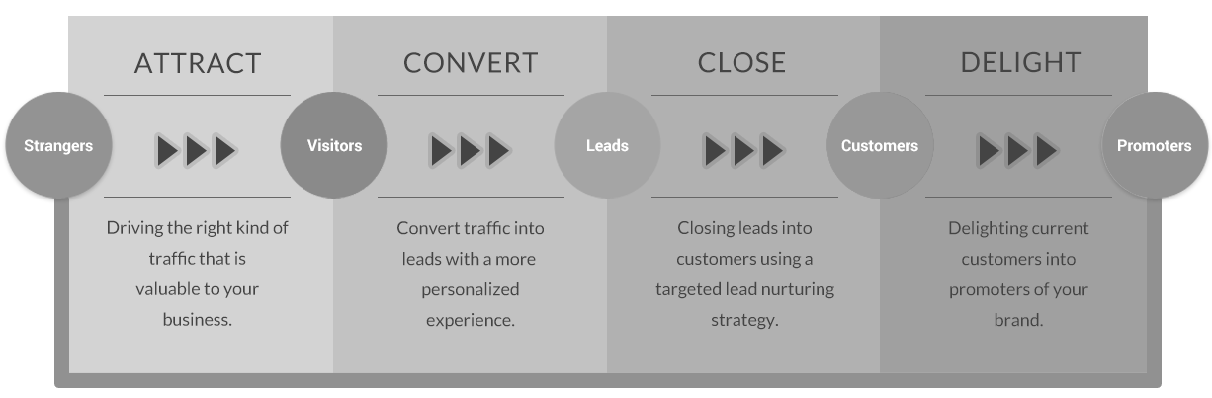

Visit MichaelDaehn.com for more marketing resources.

