Marketing Checklist

Advantage
□ Competitive Advantage □ Tagline

Purpose
□ Mission □ Vision □ Goals □ Budget □ CPA

Image
□ Promise □ Position □ Colors □ Logo

Promotions
□ PR □ Print □ Broadcast □ Sales Promotions □ Personal Selling □ Direct □ Digital

Relationships
□ Personas □ Customer Journey

Feeback
□ Surveys □ Analytics

Changes
□ Calendar □ Schedule □ Assignments

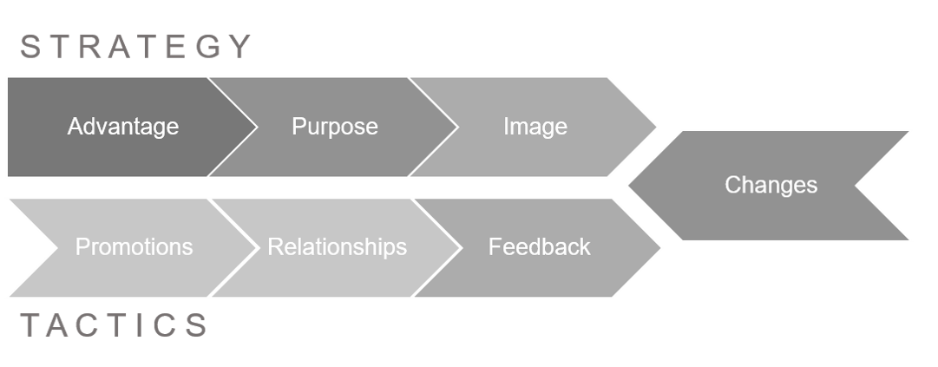
Based on The 7 Keys to Marketing Genius by Michael Daehn. Visit MichaelDaehn.com for details.

